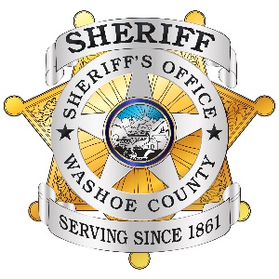
WASHOE COUNTY SHERIFF’S OFFICE
PUBLIC INFORMATION REQUEST

PLEASE FILL OUT COMPLETELY

All requests for public records will be responded to no later than the fifth business day after the request is received, in accordance with the provisions of Chapter 239 for the Nevada Revised Statutes and Washoe County Resolution Adopting Public Records Policies and Procedures. Please be advised a fee may be associated with your request and may delay the response.
Date of Request:
Name of Requestor:
Address:
Telephone:
Email:
Please provide the following information: (Be as specific as possible and include names and dates of the documents you seek. This will assist us in responding to you in a timely manner.)
Case number(s)/Date(s):
Booking number(s)/Date(s):
Person(s) involved: | 1. |  |  | DOB: |  |  | SSN:
 | 2. |  |  | DOB: |  |  | SSN:
 | 3. |  |  | DOB: |  |  | SSN:
Document(s) Requested:
 |  |  | Mugshot
 |  |  | Book/Release
 |  |  | Other | Specify:
Preferred Method of Delivery:
 |  |  | Email
 |  |  | Mail
 |  |  | In Person Pick Up
Section to be Completed by WCSO Personnel
Employee Initials: |  |  |  | ID Checked □
Department: |  |  |  | Fee Associated with Request:
Date Request Completed: |  |  |  | ____CD(s) @ $1.00/ea =
Request was: |  |  | ____ Flash Drive(s) @ $10.00/ea =
 |  |  | Emailed | Total Fees to be Collected =
 |  |  | Mailed | Date Fees Collected:
 |  |  | Picked Up

