Washoe County
Local Emergency Planning Committee (LEPC)
Grants and Finance Committee
DRAFT of Minutes
April 13, 2021, 11:00 A.M.
Regional Emergency Operations Center
5195 Spectrum Boulevard, Reno, Nevada

1. CALL TO ORDER/ DETERMINATION OF QUORUM (Non-action item)
Chair Millette called the meeting to order at 11:10 a.m. A quorum was established:
PRESENT: Brian Taylor – REMSA; Andy Ancho – RFD; Elizabeth Kunz – RPD; Eric Millette – SFD; Kelly Echeverria –WCEM; Kelly Echeverria – WCEM; Jon McNamara – RFD; Marc Bello – WCSO; Joe Kamman – TMFPD; and Roy Anderson – WCSD
ABSENT: Tracy Moore – WCSD; Jim Reid – SFD; Jack Byrom – TMWA; Christina Conti – WCHD; Paul Pertaker – RFD; Bruce Hicks – NLTFPD; Jim Nelligan – NLTFPD; Kelly McGlynn – TMWA; Pete Krall – SPD; Shyanne Schull – WCRAS; Ian Dasmann – TMWA; and Tom Nelson – RTAA
Also present: Legal – Nathan Edwards

2. PUBLIC COMMENT –
There was no public comment.

3. APPROVAL OF SEPTEMBER 24, 2020 GRANTS AND FINANCE COMMITTEE MEETING MINUTES [FOR POSSIBLE ACTION]

It was moved by Brian Taylor, seconded by Marc Bello to approve the minutes as written.
There was no public comment.
The motion passed unanimously.

4. FY 22 UWS GRANT APPLICATION REVIEW AND APPROVAL [FOR POSSIBLE ACTION] – Prioritization and approval by the LEPC Grants and Finance Subcommittee on United We Stand (UWS) grant application submissions from LEPC disciplines. The UWS grant is to support preparedness to combat terrorism for LEPC. Approved applications will be submitted to the State Emergency Response Commission (SERC). This grant is offered and funded by SERC. The amount of grant funding requests available for distribution is no more than $32,000. –
The following applications were submitted for the UWS grant.
Brian Taylor presented on option #1 for REMSA:
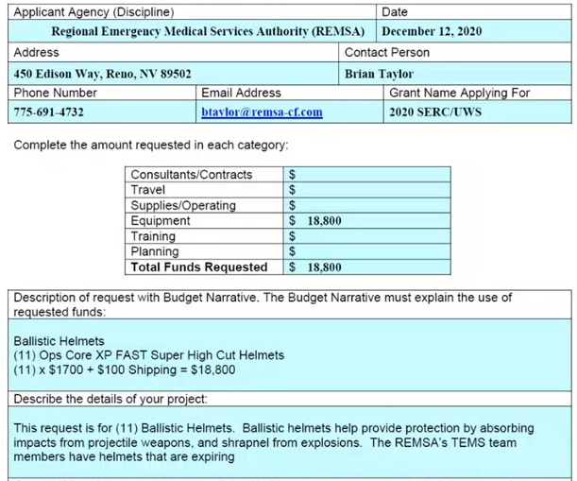
Elizabeth Kunz asked for clarification if the helmets have communication devices incorporated to which Brian Taylor said they do not.

Eric Millette presented on option #2 for RFD:
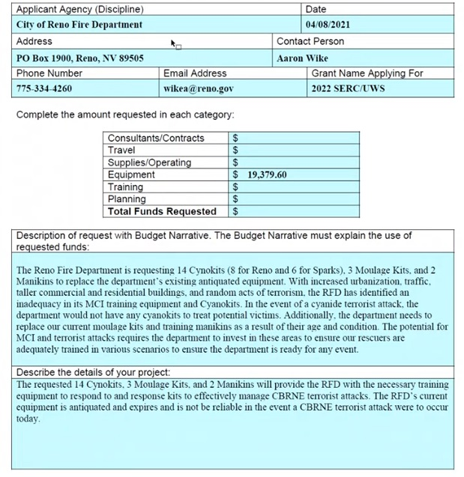
Brian Taylor ask for clarification of previously received manikins which Cindy clarified they have received them in the past.

Joe Kamman presented on option #3 for TMFPD:
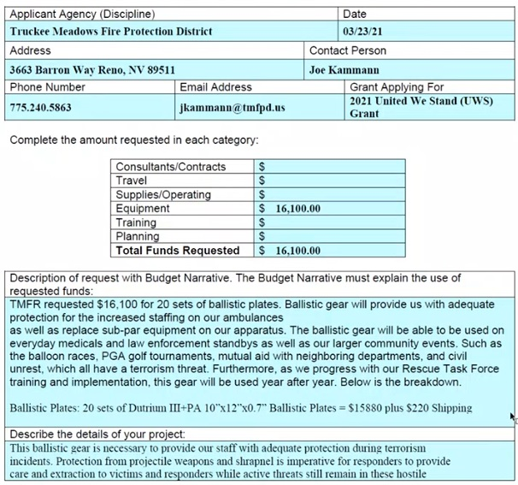

Noah Boyer presented on option #4 for WCSO:
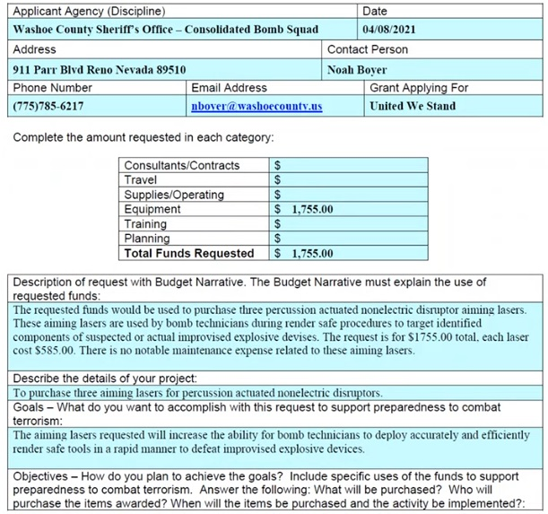
Eric Millette decided to remove RFD’s application (option #2) in favor of an HMEP grant instead.

It was moved by Eric Millette, seconded by Brian Taylor to prioritize option #4 for WCSO funded in full for $1,755, option #3 TMFPD for $15,122.50, and option #1 REMSA for $15,122.50.
There was no public comment.
The motion passed unanimously.

5. FY 21 HMEP MID‐CYCLE GRANT APPLICATION REVIEW AND APPROVAL [FOR POSSIBLE ACTION] – Approval by the LEPC Grants and Finance Subcommittee on the Hazardous Materials Emergency Preparedness Mid‐Cycle grant application submissions from LEPC disciplines. The HMEP Mid‐Cycle grant is to provide planning and training to prevent, mitigate, and respond to hazardous materials incidents. Approved applications will be submitted to the State Emergency Response Commission (SERC). This grant is offered and funded by SERC. The amount of grant funding requests available for distribution is dependent on how much funding is available at the State level. The HMEP Mid‐Cycle application is open throughout the year with no specific due date. Applications include, but are not limited to, requests made by the Reno Police Department for funding in the approximate amount of $7,770 which is for Hazardous Waste Operations and Emergency Response (HAZWOPER) trainings. –
Lt. Ryan Connolley presented on RPD CLEAR team’s application:
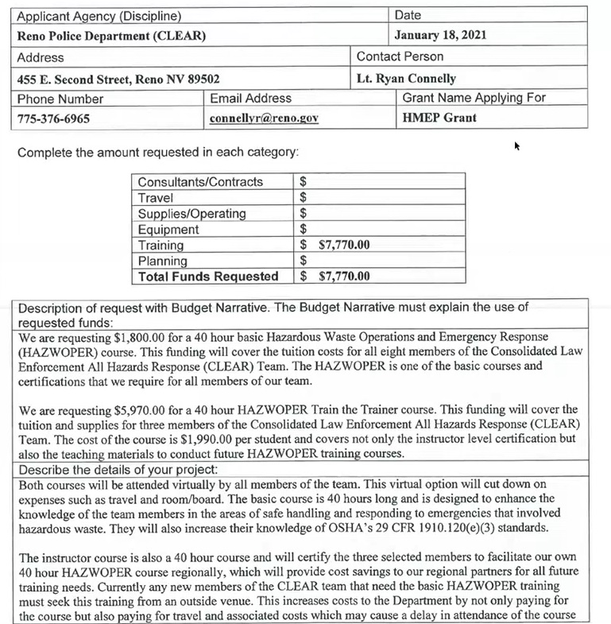

Eric Millette revisited RFD’s application which was moved from UWS to HMEP

It was moved by Brian Taylor, seconded by Kelly Echeverria to fully fund RPD for $7,770.00 and RFD for $19,379.50 in the HMEP grant.
There was no public comment.
The motion passed unanimously.

6. REVIEW OF CURRENT LEPC GRANTS AND FINANCES – Status of active grants (FY 21 Operations, Planning, Training, and Equipment (OPTE), and FY 21 United We Stand). –
Megan Sullivan presented on the following grants:
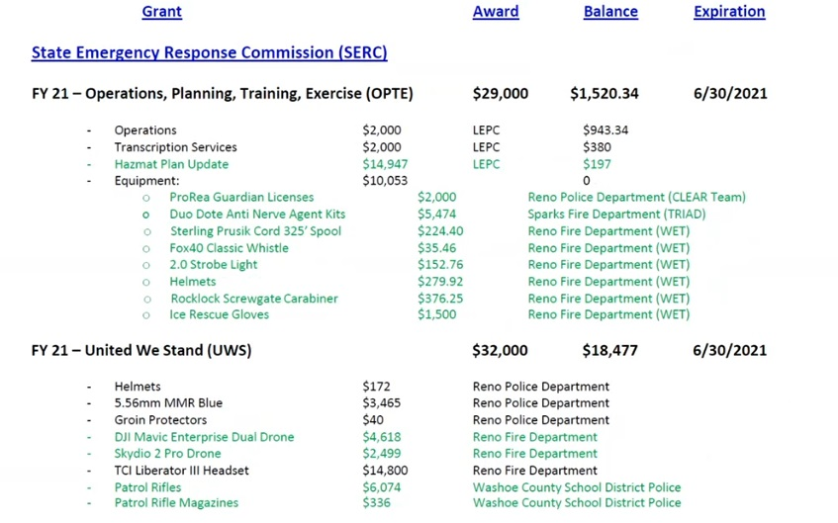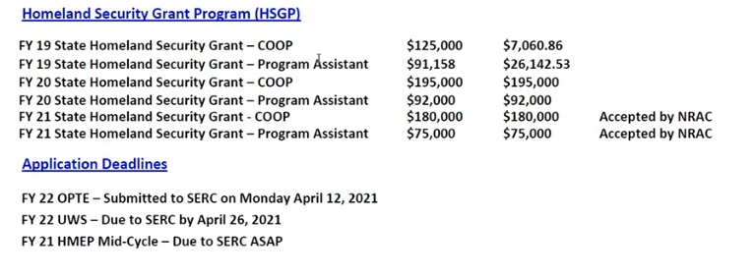
Megan Sullivan noted FY21 Homeland Security Grants - COOP and Program Assistant were accepted by Nevada Resiliency Advisory Commission for the amounts of $180,000 and $75,000.

7. COMMITTEE MEMBER AND STAFF ANNOUNCEMENTS, REQUESTS FOR INFORMATION AND SELECTION OF TOPICS FOR FUTURE AGENDAS.
Brian Taylor and Kelly Echeverria both expressed gratitude for everyone’s willingness to compromise.
8. PUBLIC COMMENT –
There was no public comment.
9. Chairman Millette adjourned meeting at 10:56

