Washoe County
Local Emergency Planning Committee (LEPC)
Minutes

December 17, 2020 10:00 A.M.
Regional Emergency Operations Center
5195 Spectrum Boulevard, Reno, Nevada

1. CALL TO ORDER/DETERMINATION OF QUORUM [Non-action item]
Chair Moore called the meeting to order at 10:02 a.m. A quorum was established.

PRESENT: Elizabeth Kunz – RPD; Ryan Connelly – RPD; Eric James – UNRPD; Roy Anderson – WCSD; Andy Ancho - RFD; Shawn McEvers – SFD; Zach Nammara – TMFPD; Eric Millette – SFD; Michelle Bays – Dist. Attorney; Aaron Kenneston – WCEM; Jessica Adams – WCEM; Chris Long – WC Tech Services; Brian Taylor – REMSA; Tammy Oliver – IHCC; Sabrina Brasuell – IHCC; Brittany Nevin – IHCC; Rob Reeder – RTC; Wade Barnett – KOLO-TV; Amanda Windes – UNR; Ian Dasmann – TMWA; and Elizabeth Breeden – NV Energy;
ABSENT: Scott Tracy – SPD; Jim Nelligan – NLTFPD; Jenna Wilch – UNRPD; Mark Jongsma – RTAA; Tracy Moore – WCSD Debbie Penrod – UNRPD; Julie Hunter – Health Dist; Charles Moore – TMFPD; Sean Garlock – RPD; Christina Wilson - SERC; Sam Hicks – TMFPD; Rob Larson – RPD; Chris Rowe – SPD; Marc Bello – WCSD; Todd Kerfoot – REMSA; Dominique LeBlanc – WCSD; John Hamilton – WCSD; Jason Trevino – WCSD; Dick Nachtsheim – RFD; Jim Reid – RFD; Jason Elorza – RFD; Ryan Sommers – NLTFPD; Bryan Calder – NLTFPD; James English – Health Dist; Shyanne Schull – WC Animal Services; Joe Kamman – TMFPD; Tom Nelson – RTAA; Charles Albee – Health Dist; Teresa Long – Health Dist; Steve Leighton – Triad; Chris Hicks – District Attorney; John Gurriere – Dist Attorney; Rebecca Knapp – RPSD; Tammy Wines-Jennings – WC Animal Services; Paul Burton – REMSA; Jessie Latchaw – IHCC; Margo Baxter – IHCC; Mechelle Arenque – VA Hospital; Angela Reich – RTC; Ed Pearce - KOLO-TV; Stanton Tang – KOLO-TV; Scott Alquist – TMCC; Ben Davis – TMCC; Spencer Lewis – UNR; Nida Harjo – RS Indian Colony; Jonathan Prichard - Pyramid Lake Pauite Tribe; David Paulon – Pyramid Lake Pauite Tribe; Rene Tyler – NV Energy; Kelly McGlynn – TMWA; Don Pelt – Pyramid Lake Pauite Tribe; Dave Hunkup – RS Indian Colony; Lance Chantler – RS Indian Colony; Quinn Korbulic – WC Tech Services; Sean Applegate – NMMC; Daniel Thayer – RS Indian Colony; Dena Avansino – RPSD; Jack Byrom – TMWA; and Dominica Yturbide – RPSD.
Also present: Legal, Nate Edwards; Christina Wilson – SERC; Brandy Saulisberry – SERC; Gayle Sherman and Ron Purcivalle – Galena Properties LLC

2. PUBLIC COMMENT –
Aaron Kenneston urged members to attend general membership meeting in order to maintain federally required minimums.
3. APPROVAL OF OCTOBER 15, 2020 GENERAL MEMBERSHIP MINUTES – FOR POSSIBLE ACTION
It was moved by Brian Taylor, seconded by Rob Reeder to approve the minutes as written.

There was no public comment.
The motion passed unanimously.
4. SECRETARY TREASURER SECRETARY/TREASURERS REPORT – INFORMATION ON EXISTING AND UPCOMING LEPC GRANTS, MEMBER INFORMATION, AND TRAININGS. –
Secretary Echeverria reviewed the following breakdown of funds. Secretary Echeverria clarified some of the amounts are pending expense receipts. Secretary Echeverria noted the amount for Continuing Challenge has been allocated to equipment per Project Change Request. Lastly, Secretary Echeverria asked for members who have attended Fireshows West to please submit their receipt for reimbursement.

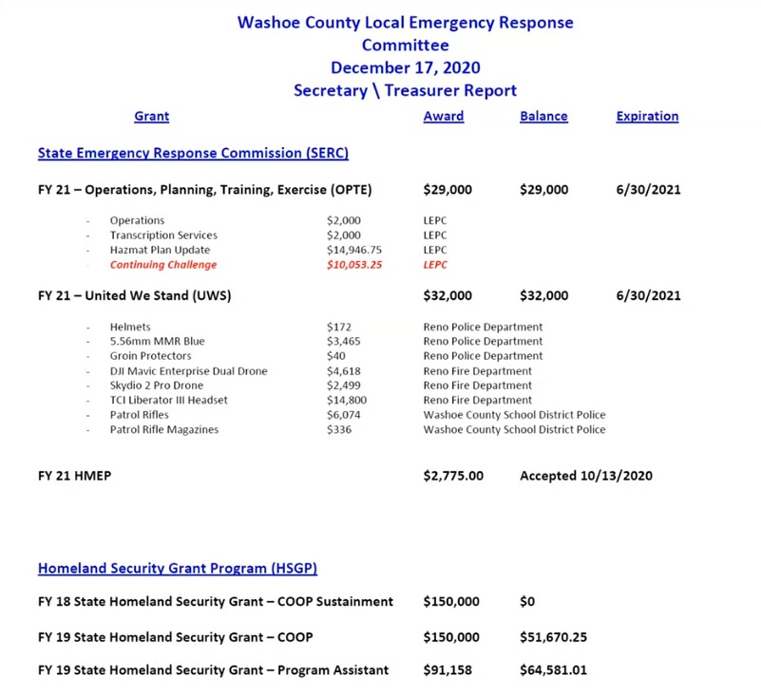
5. REVIEW OF UPCOMING GRANT OPPORTUNITIES – INFORMATION ON UPCOMING GRANTS.

Secretary Echeverria asked if any agency is looking for funding, submit applications at any time. Chairman Millette asked Christina Wilson if there are any mid-cycle grants to be had. Christina Wilson noted HMEP mid-cycle funding opportunity is open with the amount of $339,000 available to the entire state for planning activities. Christina Wilson noted the UWS second round fund are available till January 4th and she will keep everyone updated. Christina Wilson clarified the UWS funds will close June 30th of 2021. Brian Taylor asked Christina Wilson if there is a limit on amount which can be requested and Christina Wilson clarified that for the second round, no.
6. REVIEW OF THE ANNUAL LEPC PLAN UPDATE – FOR POSSIBLE ACTION – YEARLY APPROVAL OF THE UPDATED LEPC PLAN WITH FORM NRT1A, CONTACT INFORMATION, EQUIPMENT LISTS, LETTER OF PROMULGATION, AND TRAINING/EXERCISE SCHEDULES –

Chairman Millette noted the plan was updated with the idea in mind newer members can read plan and know how to proceed seamlessly. Chairman Millette noted items in this action item are required to receive grants. Chairman Millette clarified they are still waiting on some specifics for the equipment list.

It was moved by Brian Taylor, seconded by Roy Anderson to approve the approve the updated plan.

There was no public comment.
The motion passed unanimously.
7. REVIEW OF THE ANNUAL LEPC LEVEL OF RESPONSE QUESTIONNAIRE – FOR POSSIBLE ACTION – YEARLY APPROVAL OF THE WASHOE COUNTY LEVEL OF RESPONSE –

It was moved by Aaron Kenneston, seconded by Sean McEvers to approve the LEPC level of response questionnaire.

There was no public comment.
The motion passed unanimously.
8. REVIEW OF THE ANNUAL LEPC EXERCISE REPORT – FOR POSSIBLE ACTION – YEARLY APPROVAL OF THE WASHOE COUNTY LEPC EXERCISE –

It was moved by Aaron Kenneston, seconded by Andy Ancho to approve the LEPC Exercise Report.

There was no public comment.
The motion passed unanimously.

9. REVIEW OF THE ANNUAL LEPC BY-LAWS UPDATE – FOR POSSIBLE ACTION – YEARLY APPROVAL OF THE WASHOE COUNTY UPDATED BY-LAWS –

It was moved by Roy Anderson, seconded by Brian Taylor to approve the LEPC by-laws.

There was no public comment.
The motion passed unanimously.
10. REVIEW OF THE LEPC MEMBERSHIP LIST – FOR POSSIBLE ACTION – YEARLY APPROVAL OF THE WASHOE COUNTY LEPC MEMBERSHIP LIST –

Secretary Echeverria noted she will be replacing Aaron Kenneston. Roy Anderson noted the at large, chairman, and co-chair need to be updated. Sean McEvers noted an update for SFD’s alternates from Jason Elorza to Chris Jones and Jim Reid to Jim Kindness. Brittany Nevin noted Michelle Arenque as alternate for the VA Hospital. Secretary Echeverria noted Julia Ratti was added as an elected official. Nate Edwards noted changes needed to be made to website regarding name changes. Michelle Bays noted Pete Krall and Scott Tracy retired and need to be removed.

It was moved by Brian Taylor, Elizabeth Breeden seconded by Rob Reeder to approve the updated Washoe County LEPC Membership list.

There was no public comment.

The motion passed unanimously.

11. REVIEW OF THE LEPC 2019 MEETING DATES – PRESENTATION OF THE 2019 LEPC MEETING DATES –

Secretary Echeverria proposed the keep the same schedule.

12. UPDATE ON REGIONAL EMERGENCY MANAGEMENT EVENTS - A BRIEFING OF REGIONAL MEETINGS, EVENTS, TRAININGS AND EXERCISES –

Aaron Kenneston noted most evens were cancelled except for the TEPW finalization. Aaron Kenneston reminded members that any scheduled events for 2021 need to be emailed to Secretary Echeverria. Aaron Kenneston noted Incline Village evacuation drill and Upstream dam break exercise will be put onto the upcoming calendar. Brian Taylor asked IHCC to update their events to the calendar.

13. UPDATE FROM THE RADIOLOGICAL TASK FORCE - A BRIEFING ON CURRENT RADIOLOGICAL ISSUES WITHIN THE REGION -

Eric Millette noted no new information.

14. UPDATE OF WASHOE COUNTY CITIZEN CORPS - A BRIEFING ON EVENTS AND ACTIVITIES SUPPORTED BY THE WASHOE COUNTY CITIZEN CORPS INCLUDING, BUT NOT LIMITED TO, COMMUNITY EMERGENCY RESPONSE TEAMS (CERT) –

Michael Perry noted a new contact of Joe Olaciregui. Aaron Kenneston noted Citizen Corp is required to brief the region.

15. UPDATE ON STATE EMERGENCY RESPONSE COMMISSION – A BRIEFING ON GRANTS STATUS AND SERC HAPPENINGS –

Christina Wilson noted HMEP and second round of UWS grants open. Christina Wilson noted training available via an email sent to all LEPC members.
16. LEPC CHAIRMAN/BOARD MEMBER ANNOUNCEMENTS/ITEMS AND SELECTION OF TOPICS FOR FUTURE MEETINGS –

Chairman Millette noted the retirement of Aaron Kenneston to be replaced by Secretary Echeverria. LEPC members wished Aaron Kenneston well in his retirement and thanked him for his years of service.
17. PUBLIC COMMENT –
Christina Wilson noted she wishes Aaron well in his retirement.
18. Chair Millette adjourned meeting at 10:58am.

